Model for the written exam
Computer Science in English, 2nd year, 2020

I. 1. The 2nd normal form is a normalization form which helps in getting rid of data redundancy problems occurring in a relational database, maintaining data integrity and organizing data in a logical way. It is achieved when all non-key attributes are functionally dependent only on the primary key, and all attributes of the relation are atomic(1NF).

2. The cross join algorithm takes place between two tables, and the number of rows of the result set is equal to the product of the number of rows of the first table and the number of rows of the second table. It is obtained by taking each row of the first table and joining it with each row of the second table. It returns all possible combinations of rows from the two tables.
Example:
Table1:
Attribute1 | Attribute 2
“ABC” | 54
“Z” | 123

Table2:
Attribute100 | Attribute101
134 | 423
1231 | 124

Table1 CROSS JOIN Table2:
Attribute1 | Attribute 2 | Attribute100 | Attribute101
“ABC” | 54 | 134 | 423
“ABC” | 54 | 1231 | 124
“Z” | 123 | 134 | 423
“Z” | 123 | 1231 | 124

II. 1. a.
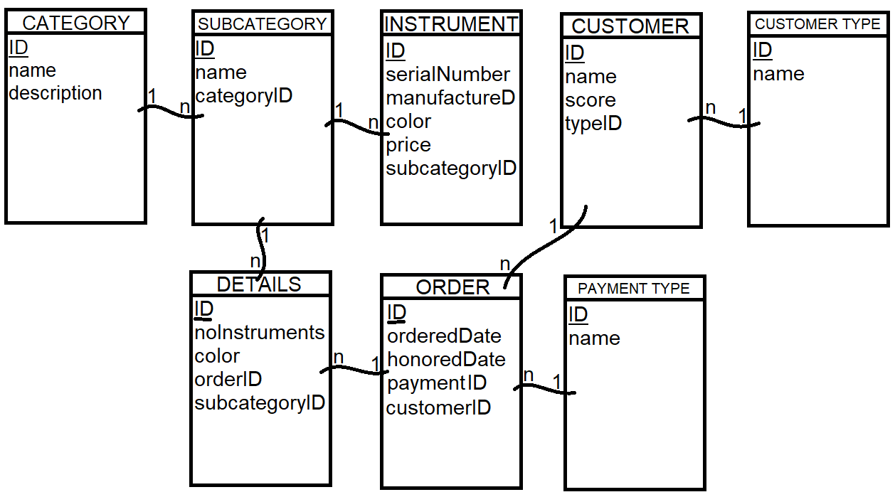

b.
CREATE TABLE Order (
ID int primary key identity(1, 1),
orderedDate datetime,
honoredDate datetime check(honoredDate > orderedDate),
paymentID int references PaymentType(ID),
customerID int references Customer(ID)
)

2. a.
SELECT t.ID, t.TotalNumInstruments
FROM (
SELECT Cus.ID, SUM(noInstruments) TotalNumInstruments
FROM Customer Cus INNER JOIN Order Or ON Or.customerID = Cus.ID
INNER JOIN Details De ON De.orderID = Or.ID
GROUP BY(Cus.ID)
) t
WHERE t.ID in (
SELECT Cu.ID
FROM Customer Cu INNER JOIN Order O on O.customerID = Cu.ID
INNER JOIN Details D ON O.ID = D.orderID
INNER JOIN Subcategory S ON S.ID = D.subcategoryID
INNER JOIN Instrument I ON I.subcategoryID = S.ID
INNER JOIN Category C On C.ID = S.categoryID
WHERE C.type = ‘orchestra’ and S.name = ‘violin’
GROUP BY Cu.ID
HAVING COUNT(DISTINCT O.ID) >= 3
)

b.
In T-SQL:
SELECT S.name, I.serialNumber, I.price
FROM Instrument I INNER JOIN Subcategory S ON I.subcategoryID = S.ID
INNER JOIN Category C ON S.categoryID = C.ID
WHERE I.price < 2000

In relational algebra:
π {Subcategory.name, Instrument.serialNumber, Instrument.price} (
σ Instrument.price < 2000 and Category.name = ‘string’
(Instrument * Subcategory * Category)
)

III.
1. Correct answer/s: a, d
2. Correct answer/s: b
3. Correct answer/s: c
4. No repeating attributes => 1NF
{F} – not a key
{F} -> {H} => it is not in 2NF => it is not in 3NF => it is not in BCNF => …
Correct answer/s: c
5. Correct answer/s: a, b
6. alfa -> beta, alfa -> gamma => alfa -> beta x gamma
Correct answer/s: e
7. c
8.
|Q1| = 9
|Q2| = 6
|Q1| – |Q2| = 3
Correct answer/s: b
9. Correct answer/s: a
10. Correct answer/s: a
11. Correct answer/s: a, c
12.
AB
A | B
a1 | b2
a1 | b1
a2 | b1

BC
B | C
b2 | c1
b1 | c2
b1 | c1

AC
A | C
a1 | c1
a1 | c2
a2 | c1

AB * BC
A | B | C
a1 | b2 | c1
a1 | b1 | c2
a1 | b1 | c1
a2 | b1 | c2
a2 | b1 | c1

AB * BC * AC
A | B | C
a1 | b2 | c1
a1 | b1 | c2
a1 | b1 | c1
a2 | b1 | c1

=> 1 extra record: (a1, b1, c1)
Correct answer/s: b

IV. E = 𝛱 {P.P2,Q.Q2, Q.Q4, R.R3}
(
𝜎P.PID = Q.Q1 AND Q.QID = R.R2 AND P.P3='Bilbo' AND Q.Q5 = 100 AND R.R1=7 (P×Q×R)
)

E = 𝛱 {P.P2,Q.Q2, Q.Q4, R.R3}
(
𝜎 P.PID = Q.Q1 AND Q.QID = R.R2 ((𝜎 P3='Bilbo' P) × (𝜎 Q5=100 Q) × (𝜎 R1=7 R))
)

E = 𝛱 {P.P2,Q.Q2, Q.Q4, R.R3}
(
𝜎 P.PID = Q.Q1 AND Q.QID = R.R2 ((𝜎 P3='Bilbo' P) × ((𝜎 Q5=100 Q) × (𝜎 R1=7 R)))
)

E = 𝛱 {P.P2,Q.Q2, Q.Q4, R.R3}
(
𝜎 P.PID = Q.Q1 AND Q.QID = R.R2 ((𝜎 P3='Bilbo' P) × ((𝜎 Q5=100 Q) × (𝜎 R1=7 R)))
)

E = 𝛱 {P.P2,Q.Q2, Q.Q4, R.R3}
(
(𝜎 P3='Bilbo' P) ⨂ PID = Q1 (𝜎 Q.QID = R.R2 (𝜎 Q5=100 Q) × (𝜎 R1=7 R))
)

E = 𝛱 {P.P2,Q.Q2, Q.Q4, R.R3}
(
(𝜎 P3='Bilbo' P) ⨂ PID = Q1 ((𝜎 Q5=100 Q) ⨂ Q.QID = R.R2 (𝜎 R1=7 R))
)

E = 𝛱 {P2} (𝜎 P3='Bilbo' P) ⨂ PID = Q1
(
𝛱 {Q2, Q4} (𝜎 Q5=100 Q) ⨂ Q.QID = R.R2
(𝛱 {R3} (𝜎 R1=7 R)
)

